I must congratulate you again for your superb playing ---- super pitch and fascinating use of tone colours.
You made those completely unknown pieces sound very interesting.
Bravissimo!!!
Yours
Wibb (William Bennett OBE)

FLUTE, the magazine of the British Flute Society
British Flute Festival August 2012 Manchester (UK)

Aldo Baerten with Timothy Carey

Aldo Baerten has a gloriously rich and expressive sound, with effortlessly controlled technique, and this recital displayed an intensely lyrical interplay between the performers.
…..
there were many magical moments....
A plaintive third movement ….sensitive and eloquent with a glorious flexibility of sound, colour, and expression, building to a wonderful climax.....

FLUTE TALK JULY AUGUST 2016
French Recital
Baerten's playing is quite extraordinary in his tasteful, musical performances especially in his use of colors and a wide range of dynamics. No doubt Baerten's experience as principal flutist of the Royal Flemish Philharmonic contributes to his expressive recording of the Debussy Prélude à l'Apres-midi d'un Faune..this CD is full of truly exciting performances....

Aldo Baerten is Principal Flutist at the Royal Flemish Philharmonic (Antwerp Symphony Orchestra as from 2017), conducted by Edo de Waart, Philippe Herreweghe and Martyn Brabbins. Www.defilharmonie.be

He is Professor for flute at the Royal Conservatoire in Antwerp, at the Hogeschool der Kunsten Utrecht (NL) and gives masterclasses on 4 continents, in such distinguished schools as the Royal Academy London.
Aldo Baerten is former Professor for flute at the Sydney Conservatory, and during the 2015/16 academic year at the Münster Musikhochschule Germany.
As from October 2016 he will be teaching at the Hochschule für Musik, Theater und Medien Hannover.
He is a regular guest at the Swedish Chamber Orchestra, Chamber Orchestra of Europe, Mahler Chamber Orchestra, I Fiamminghi, European Union Opera, Arctic Philharmonic and the Rotterdam Philharmonic Orchestra..

During his studies at the Royal Conservatory in Brussels, with Prof. Peter-Lukas Graf (Musikhochschule Basel), where he obtained the Diploma as a Soloist and with Philippe Boucly (R.Strauss-Konservatorium München), he became Prize-winner in competitions such as “Maria Canals” (Barcelona 2001), Vienna (2004), Axion Classics, Quantz, and the National Instrumentcompetition of Belgium.
He received the Alex de Vries-prize, the SABAM-award, and the Caecilia-prize of the Belgian music-press.

Aldo Baerten played as a soloist with eminent orchestras as the Südwestdeutsches Kammerorchester, RSO Basel, National Orchestra of Belgium, Walloon Chamber Orchestra, the Royal Flemish Philharmonic, Las Vegas and Kansas City Symphony, Samaai Sinfonietta under the baton of D. Stern, V. Czarniecki, P. Rundel, G. Octors, Z. Nagy, T. Yuasa, S. Byess, E. Aadland, R.Wilson, S.Mäkkilä.....

He is a regular guest at festivals around the world, together with famous musicians such as J.van Dam, Martin Helmchen, Severin Von Eckardstein, Martin Spangenberg, Niek de Groot, StorioniTrio, Michel Strauss, Alexei Ogrintchouk, Hervé Joulain, Kandinsky-trio, Jana Bouskova, Dietrich Henschel, Tatjana Masurenko, jazz pianist Jef Neve....

Aldo Baerten has recorded extensively on Cypres, Phaedra, ECM, Pentatone and PMP and Principal Chairs.
His recording of Schuberts Introduction, Theme and Variations on Trockne Blumen (die schöne Müllerin) with pianist Martin Helmchen was nominated for the BBC Music Prize of best chamber-music recording of the year 2010.

From 1989 until 1993 he was Principal Flutist with Claudio Abbado’s Orchestra of the E.U, where he has played under conductors such as B. Haitink, V. Ashkenazy, V. Neumann, J. Conlon and J. Tate. He was also chosen as Principal of the Schleswigholstein Festival Orchestra (Sir G.Solti) and the World Youth Orchestra.
Aldo Baerten was the Principal Flutist of the Belgian Chamber Orchestra and the MDR-Sinfonieorchester Leipzig.

His yearly summerclass International Flute Seminar Bruges is a highlight for professionals and amateurs. Www.ifsb.be

Aldo Baerten is Powell Flute artist.

Aldo Baerten is a regular Jury-Member of the International Flutonicon Flute Competition, Axion Classics, Lyons-music-competition, NFA Young Artists Competition , Yamaha Music Foundation and Biwako (Japan).
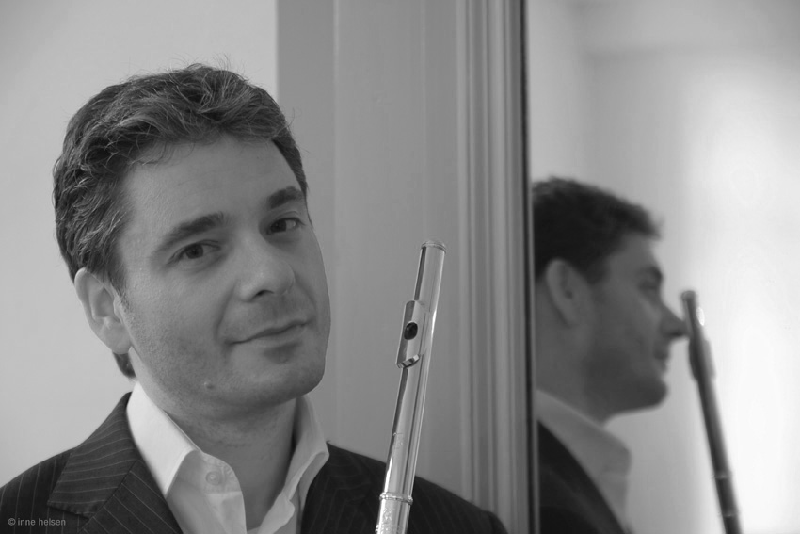
His students occupy positions in orchestras and conservatories in Belgium and abroad.
Www.aldobaerten.com

