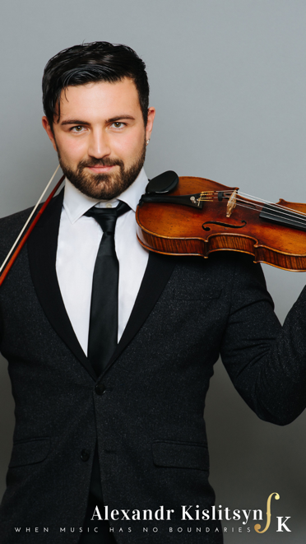 Alexandr Kislitsyn was born into a musical family with a long tradition in the arts. From a young age, his parents - both highly-trained and accomplished musicians - sought to encourage him to carry on in the family tradition, an endeavor mitigated by Alexandr's determination. Ungratified by kindergarten's monotony, he willfully launched his informal musical training by trailing his mother to her rehearsals with the Omsk Philharmonic Symphony Orchestra. His formal training began shortly after that, and he went on to earn a Bachelor of Arts in Violin Performance from Novosibirsk State Conservatory and a Master's degree in Violin Performance from Temple University.

​

Alexandr made his debut as a concert violinist with the symphony orchestra at the tender age of 6. Since then, he has gone on to concertize throughout Russia, Europe, Asia, and North and South America teaching masterclasses, giving solo recitals and performing with symphony orchestras as well as chamber ensembles in such notable venues as Carnegie Hall, Walt Disney Concert Hall, Kimmel Center, Thailand Cultural Centre Hall, etc. Winner of numerous national and international competitions and recipient of multiple prestigious musical awards, his extensive repertoire includes significant works from solo and chamber literature.

​

     As an experienced orchestral musician, Alexandr has performed with orchestras for diverse and distinguished audiences worldwide. He was a soloist and member of the Omsk Philharmonic Chamber Orchestra (2006-2008); principal of the Novosibirsk Conservatory Symphony Orchestra (2008-2012); guest artist of the Novosibirsk Academic Philharmonic Symphony Orchestra; member of the string ensemble, "Bright Bows" (2008-2013); guest artist in the Symphony Orchestra of the Novosibirsk State Academic Opera and Ballet Theatre (2009); assistant principal of the International Symphony Orchestra, performing for heads of state attending the ASEAN Financial Summit (2010); artistic director and principal violin for the Novosibirsk Drama Theatre's rendition of "Red Torch" (2011-2013); member of the International Symphony Orchestra of the 14th International Festival of Opera and Ballet in Thailand, where the orchestra presented a global project of the BBC's "Planet Earth" under the patronage of the Thai Royal Family (2012); member of the iPalpiti International Festival (2013-2017); principal of Temple University Symphony Orchestra (2015-2016); member of the Philadelphia International Festival (2016), member of Symphony in C Orchestra (2016 - current); substitute member of the Chamber Orchestra of Philadelphia (2018 - current); substitute member of the Curtis Symphony Orchestra (2018 - current); substitute member of the Philly POPS (2020 - current); substitute member of the Academy of Vocal Arts (2020 - current); the violinist at the 49 Burning Condors (2019 – 2020); As a chamber musician, Alexandr has participated in a plethora of musical projects and appeared on multiple concert stages around the globe. Currently, he is an artist at the Parma Recordings and a member of the Trio Casals.  Besides classical music, Alexandr is developing a career as an electronic music producer while writing for other artists in various genres.   
       
      Offstage, he has served as a youth violin instructor with Temple University Music Preparatory (2014-2016), Nelly Berman School of Music (2016 - 2017), The Baldwin School (2017-2018), Symphony in C Youth Orchestra (2017 - current), Symphony in C Summer Camp (2018 and 2019), the Young Musicians Debut Orchestra (2020 - current) training the next generation of inspired musicians.