Boris Khusid  Cello  City: Arad, State of Israel  Work schedule: Full time/Part time | 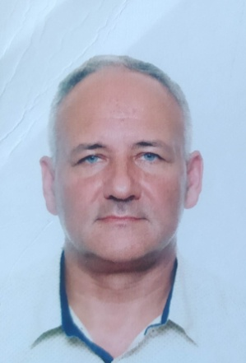
PERSONAL INFORMATION | Citizenship: State of Israel, Russian Federation  Education: MA
CONTACT INFORMATION | Phone: 055-7717908  Email: borisk8180@gmail.com
EXPERIENCE | Orchestral and Ensemble Experience  November 1990 – August 1995:  Moscow Philharmonic orchestra, Moscow, Russia – Section cello  October 1995 – August 2004 (freelance section cello):  Westmoreland Symphony orchestra, Pittsburgh, PA (principal cello)  McKeesport Symphony orchestra, Pittsburgh, PA, USA  Johnstown Symphony orchestra, Johnstown, PA, USA (principal cello)  Wheeling Symphony orchestra, Wheeling, PA (assistant principal cello)  Akron Symphony orchestra, Akron, PA  Spoleto festival USA, Charleston, SC, USA  December 2024 – Now  The Israel Sinfonietta Beer Sheva – freelance section cello  Performed chamber music with smaller parts of the orchestras and solo with orchestras as well  Teaching experience  September 2003 – June 2004:  Indiana University of Pennsylvania, Indiana, PA, USA  Cello and Bass teacher for college students.  October 1995 – August 2004:  Private cello lessons  October 2004 – June 2024  Private cello lessons ( tutoring) Moscow, Russia
EDUCATION | September 1983 – June 1990:  Gnesin Academy of Music, Moscow, Russia  Diploma with honors
PROFESSIONAL SKILLS | Languages: Russian (native), English (advanced)

