Curriculum Vitae
Daniela Petkoska
 |  | I 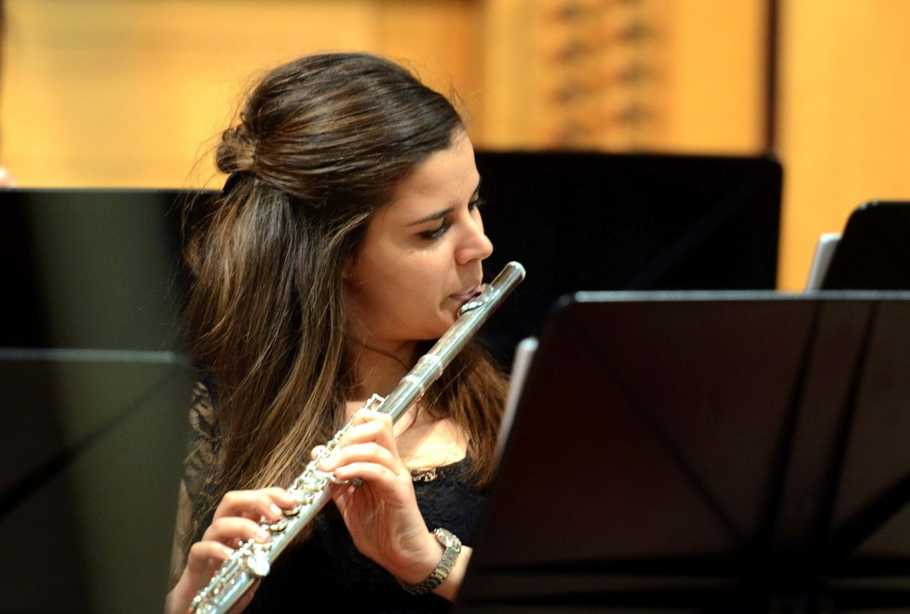
Personal information:
First name and Surname  Telephones: |  | - Daniela Petkoska  - Mobile: +393896528026; +38978729164;
Address(es) |  | - Via Gaspare Gozzi 5, 34134, Trieste, Italy  - Ulica Radojca Novichikj 164, 6000 Ohrid, Macedonia
E-mail  Nationality  Date and place of birth  Gender |  | dance.danila@hotmail.com  - Macedonian  - 16.08.1993 Ohrid, Macedonia  - Female |  |  |  |  | .
Work experience  Dates and work places  Education and training  Title of qualification awarded |  | - 2013-2015 Principal Flute, II Flute, III Flute and piccolo in the Simphony Orchestra in Skopje, Macedonia.  - 2014-2015 Played Piccolo in the orchestra in the Opera and Balet music in Skopje, Macedonia.  - 2015-2016 Worked as a flautist in the MOB (Macedonian opera and balet) in Skopje, Macedonia.  - Third flute in James Galway Flute ensemble in Milan Italy.  - 2015-2016 Principal Flute and II Flute in the Simphony Orchestra in Trieste, Italy.  - November 2016 Principal flute in International orchestra Szczecin projects in Poland and Germany in Berlin, Neubrandenburg and Szczecin.  - 2016-2017 Principal Flute in the Sympohony Orchestra in Trieste, Italy.  - January 2018 Principal flute in International orchestra Szczecin projects in Poland and Germany in Berlin, Pasewalk and Szczecin.  - 2017-2018 - present Second year of master studies at the Conservatory of Music  Giuseppe Tartini in Trieste, Italy.  Previous education:  - 2002 – 2008 Elementary music school Methodius Patche in Ohrid, Macedonia.  - 2008 – 2012 State Music High School in Bitola, Macedonia.  - 2012 – 2014 Faculty of Music Arts in Skopje, Macedonia.  - 2014 – 2016 Conservatory of Music Giuseppe Tartini in Trieste, Italy.  Numerous special national awards (100 points) as a soloist and chamber music.  - 2014 Awarded 1st Prize Flute Category at the State Competition for Young musicians in Macedonia.  - 2017 Awarded 1st Prize at the Lilian Caraian flute competition in Trieste, Italy.
Title of qualification awarded |  | - 2011 Had a performance as soloist at the Reinecke flute concert with Macedonian Philharmonic Orchestra in Skopje Macedonia.  - 2012 Awarded 1st Prize in flute category and 3rd Prize at the  European Union of Music Competitions for Youth in Ohrid, Macedonia.  - 2013 Performed Premiere of Hue’s flute fantasy for the first time in Macedonia with Symphony Orchestra.  - 2013 Awarded 1st Prize Flute Category at the International Competition  Tahir Kulenovic in Valjevo,Serbia.
Principal subjects/occupational skills covered |  | - Participation in many cultural events, concerts and solo recitals in Macedonia, Serbia, Italy, Germany, Poland.
Name and type of organisation providing education and training  Personan skills and  performances |  | - 2008 – 2012 State High School in Bitola - Prof. Aleksandar Stefanovski  - 2012 – 2016 Faculty of Music Arts in Skopje – Prof. Strasho Temkov, Bachelor Degree  - 2015 – 2016 (ERASMUS exchange program) Conservatory of Music Giuseppe Tartini in Trieste, Italy - Prof.Giuseppina Mascharetti, Bachelor Degree  - Attended and participated in Flute Master classes by European popular professors as listed below:  - Prof. Matthew Zupan - Slovenia  - Prof. Claudio Ferrarini - Italy  - Prof. Dejan Gavric - Germany  - Prof. Giuseppina Mascharetti - Italy  - Prof. Gabriele Betti - Italy  - Attended and participated in Flute Master classes made by famous flutists in the world:  - Sir James Galway - Switzerland  - Lady Jeanne Galway - USA  - Raffaele Trevisani - Italy  - Emmanuel Pahud - France  - Davide Formissano - Italy  - Bulent Evcil - Turkey  - Hang Guoliang - China  - Hiroshi Matsushima - Japan  - Talented, Highly motivated, dedicated to learning and practicing.
Mother tongue |  | - Macedonian
Other language(s) |  | - English, Italian
Self-assessment |  |  | Understanding |  |  |  |  | Speaking |  |  |  |  | Writing
European level (*) |  |  | Listening |  | Reading |  |  | Spoken interaction |  | Spoken production
Language |  |  |  | English |  | C1 |  |  | C1 |  |  | C1 |  | C1
Language |  |  |  | Italian |  | C1 |  |  | C1 |  |  | C1 |  | C1
 |  | (*) Common European Framework of Reference for Languages
Social skills and competences |  | - Communicative, creative,
Organisational skills and competences |  | - A good team worker, leading features.
Technical skills and competences |  | - Music performance, soloist with orchestra, performance in orchestra, play flute, piano, piccolo.
Artistic skills and competences |  | - Play concerts, solo recitals, play in orchestra, chamber music

