Isabelle Rozendaal

Performer and Teacher: Violin, Baroque Violin

1216 W. Sherwin Ave. • Chicago, IL 60626 • isabellerozendaal@gmail.com • 312 501 3705

EDUCATION:

2013-2015 DePaul University School of Music Masters in Music - Violin Performance
2006-2009 Oberlin Conservatory of Music - Violin Performance (Oberlin, OH)

OTHER TRAINING:

2013 Indiana University Jacobs School of Music: Retreat for Violin and Viola Teachers; Session I

2013 Northern Kentucky University: Mark O’Connor Method Teacher Training with Pamela Wiley
2006-2009 Suzuki Association of the Americas Registered Training: Violin Books 1-6
2001-2006 Northwestern University String Academy - Violin (Evanston, IL)
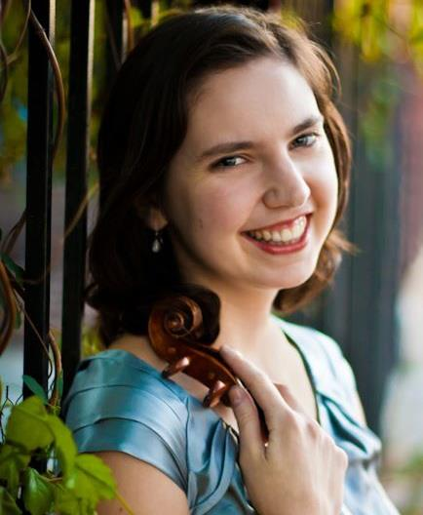

PERFORMANCE EXPERIENCE:

- 2015 - present: Principal Second Violin, Park Ridge Symphony Orchestra
- 2015: Concertmaster: Handel’s Ariodante, Chamber Opera Initiative (Evanston, IL)
- 2012 - 2015: Northwest Indiana Symphony Orchestra
- 2014: New Philharmonic (Glen Ellyn, IL)
- 2007 - 2014: Baroque Band Assistant Concertmaster, Ravinia Festival concert & recordings (Cedille Records)
- 2013 - 2014: South Florida Symphony Orchestra (Key West, FL)
- 2013: Trans-Siberian Orchestra West Coast Tour
- 2013: Rockford Symphony Orchestra
- 2013: Illinois Symphony Orchestra
- 2011 - 2012: Adagio String Quartet: Holland America Cruise Contract (New Zealand, Australia, Canada)
- 2011: WFMT Chicago Classical Radio Live Broadcasts from International Beethoven Project Festival
- 2011: Soloist and Assistant Concertmaster with Bensenville Chamber Orchestra
- 2011: Concertmaster of Oberlin College Orchestra

PRINCIPAL TEACHERS:

2013-2015 Janet Sung at DePaul University School of Music
2006-2009 Marilyn McDonald and David Bowlin at Oberlin Conservatory of Music

2006 Blair Milton at Northwestern University
2001-2006 Stacia Spencer at Northwestern University String Academy

MUSIC FESTIVALS:

2013 Northwest Festival Orchestra, Harper College (Palatine, IL)
2008-2011 Green Lake Choral Festival Orchestra Member

2006 Baroque Performance Institute at Oberlin Conservatory
2005 Indiana University String Academy Summer Program
2002, 2003, 2004 Northwestern University Music Institute Summer Program

TEACHING EXPERIENCE:

2012- 2016: Suzuki Violin Teacher at WISH Program – Chicago West Community Music Center
2014- Current: South Side Suzuki Cooperative – Violin Faculty

OTHER:

2012: Music Librarian for Innocenti Strings
2011-2012: Masters Education Course at National Lewis University (Chicago, IL)
2011-2012: Yoga Instructor at Sherwin Yoga Center (Chicago, IL)
2011: Oberlin College: BA in Comparative American Studies - Histories and Practices of Social Change: Environmental Justice. Minor: Gender, Sexuality and Feminist Studies
2010-2011: Solaluna Yoga Studio: Yoga Teacher Training 200 and 500-hour (professional level) certifications (Oberlin, OH)
2010-2011: Solaluna Yoga Studio Work-Study Intern, Yoga teacher-in-training
2006: Awarded Marilyn McDonald Merit Scholarship for study at Oberlin Conservatory of Music

