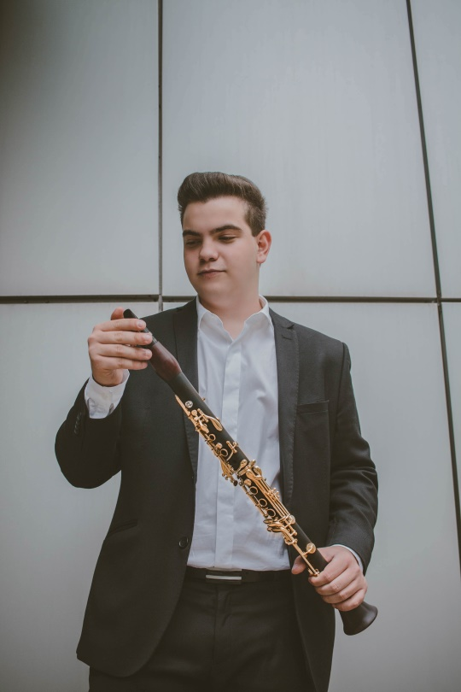**JOSÉ MANUEL ACEVEDO REAL**

**Clarinet**

He was born in Ciudad Real (Spain) in 2001. He began his musical studies at the age of 5. In 2009 he began the Elementary Education at the Professional Conservatory of Music “Marcos Redondo” in Ciudad Real, clarinet being his specialty, finishing here his Professional Education in the academic year 2018/2019 getting tuition of honor on his final degree exam, having   
Bernardo Moreno Bertomeu as his teacher, and later Justo Sanz.

He is currently studying 2nd of Bachelor Education at the “Conservatorio Superior de Música de Castilla La Mancha” in Albacete with Professor Efrén Ramos Morado and at the same time receiving classes from Venancio Rius.

He attended masterful lessons by Venancio Rius, Yehuda Gilad, Paul Meyer, Justo Sanz,   
Mark Van de Wiel, Enrique Pérez Piquer, Carlos Gustavo Duarte, José Jorge Gasulla,   
Miguel Espejo, Camilo Irizo and Eduardo Raimundo. In addition to this, he received master chamber music classes by Patricia Arauzo and Alejandro Bustamante, and several professors from the Royal Academy of Music and Royal College of Music in London. He has received awards in competitions such as “*Premio Internacional de Interpretación Intercentros Melómano*” in Alicante (2018) and “*IX Concurso de Solistas*” in Ciudad Real (2019). Futhermore, he is currently participating in *Joven Orquesta de la Comunidad Autónoma de Castilla la Mancha*, *Orquesta Juvenil Europea de Madrid (OJEM)*, In Albis Ensemble, *Orquesta Proyecto 10*, Joven Orquesta Leonesa, *Pantueña Wind Orchestra (PWO) and European Union Youth Wind Orchestra (EUYWO)*, in addition to being selected and participating in courses such as Klangforum Schweiz - Akademie für Ensemble- und Orchesterkultur in Switzerland; and the British Isles Music Festival in London.