**Denysov Mykyta**

23.11.1991

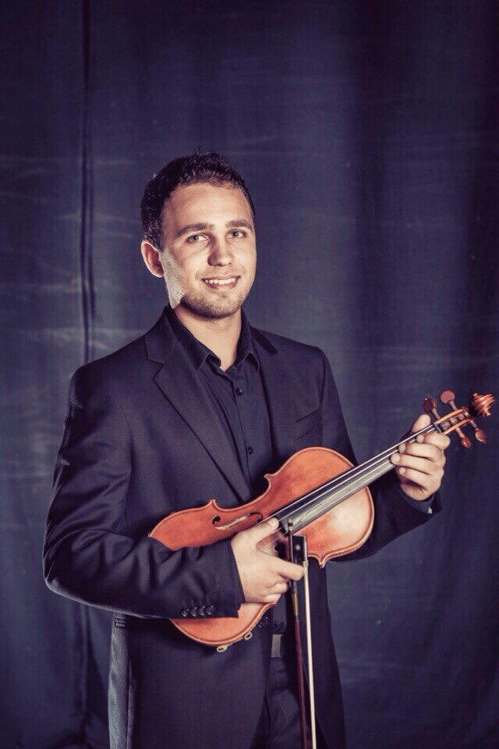

Professional violin player / violin teacher

Male

Marital status: Married

Location: Kharkiv, Ukraine

Nationality: Ukrainian

Email: nikitadenisov4@gmail.com

Skype: Nikita Denisov

**Personality**:

Energetic and creative musician.I have a varied repertoire. Also good sight-read and good pick up by ear. I strive every time to learn something new. I like to act as a trio/duo/orchestra and love to make people happy.

**Education:**

2006-2010 Simferopol Music College

2010-2014 Kharkov National University of Arts

Musical art - "Bachelor".

2014-2015 Kharkov National University of Arts

Musical art - "Specialist"(master)

2014-2015 Kharkov Government Academy of Culture

"Master"

Higher education in the specialty of "Musical art», qualification of orchestra performer, ensemble performer,researcher;lecture of a higher school institution.

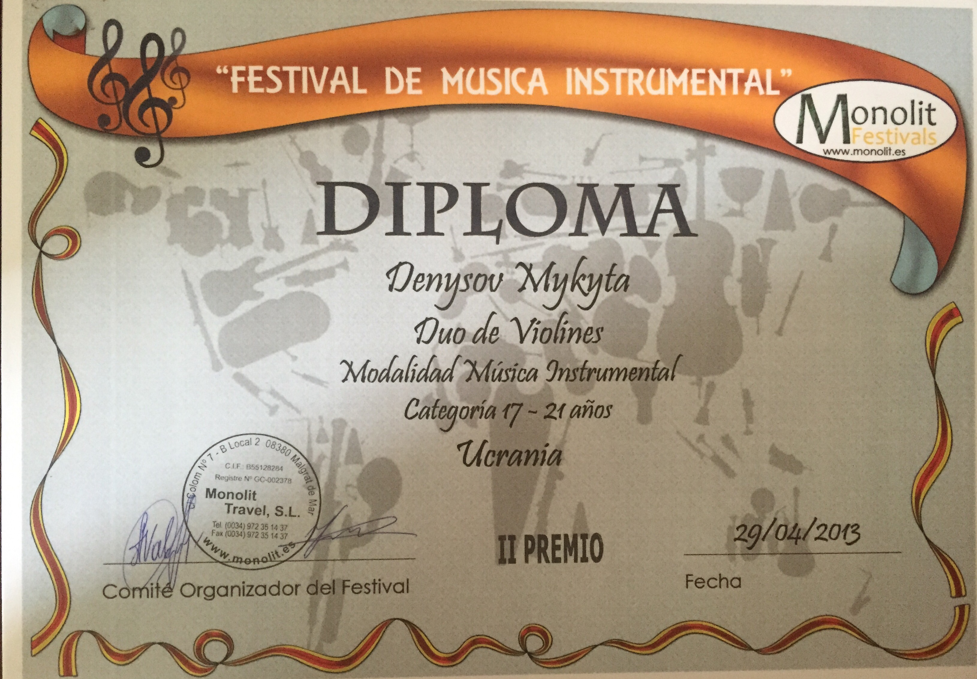

**Professional skills**:

Laureate of international competitions:

“Crimea Spring” (April 2012) (Ukraine,Yalta)

“Monolit Festival” (Spain -May 2013)

**Video**:

String Trio “Black Diamonds”

<https://youtu.be/sznOPuOG8Rw>

Demo Trio “Black Diamonds”

<https://youtu.be/q_Us0LTW-C0>

String Duo “Black Diamonds”

<https://youtu.be/VIcFk1aJu1Q>

Video from teaching lesson

https://youtu.be/9xqjJ2pl6wE

Video from violin solo

<https://youtu.be/BliBhLyaSy8>

**Teacher Experience:**

2014-2015 Violin teacher in Kharkiv Music School #8

2011-2017 Private teacher of Music (Violin/Viola/Piano)

**Ship Experience:**

2016: NCL – “Norwegian Sun” – Classical String Trio

2017: Carnival – “Paradise” – String Duo

2017: Carnival – “Pride” – String Duo

2017: NCL – “Norwegian Sun” – Classical String Trio

2017: Carnival – “Pride” – Electric String Duo

2017: Carnival – “Sensation” – Electric String Duo

**Experience:**

2006-2010 Classical Symphony Orchestra.Simferopol Music College.

2010-2015 Classical Symphony Orchestra.Kharkiv National University of Arts.

2010-2015 string quartet player.

2011-still now solo violin player

2011-2015 Chamber Music (duet piano)

2011-2014 Chamber Orchestra "Fortunati"

2011-2012 artist of “Kharkiv Academic Youth Symphony Orchestra Slobozhanskiy”

2014-2015 violin artist of symphony show "World Hits".

2014-2015 Piano Trio "Dolce Vita"

2015 String Trio/Duo "Black Diamonds"

2015-2016 Kharkiv State Philharmonic tour in Spain and Italy

I have performed in many Spanish concert halls like **Palacio de la Música Catalana (Barcelona), Auditorio Nacional de Música (Madrid) , Euskalduna Conference Centre and Concert Hall (Bilbao) , Auditorio - Palacio de Congresos de Zaragoza (Zaragosa) , Kursaal Congress Centre and Auditorium (San Sebastian), Teatro Gayarre (Pamplona), Palau de la Música de València**

**(Valencia)** and other.

Also I have concerts as a classical artist and electro violin player.

**Seaman's book :** available

**Visa : C1/D** available

**Languages:**

English - fluent

Russian - native

Ukrainian – native