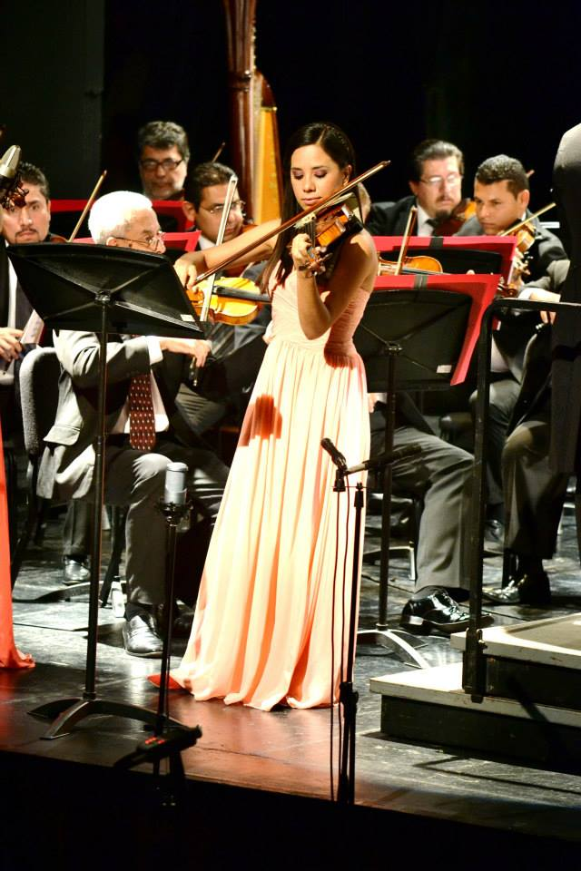

|  |  |
| --- | --- |
| Personal Details |  |

Name: Nancy Parra Avila  
Date of birth: 24/02/1989  
Address: Via Lombarda 169, Capannori. LU, Italia  
Phone: +39 331 261 6074  
E-mail: [nancyparra1920@gmail.com](mailto:nancyparra1920@gmail.com)

|  |
| --- |
| Education |

**Bachelor in Music** 2010-2015 Universidad de Guadalajara/ Mexico  
**Artist Diploma** 2015-2017 San Francisco Academy Orchestra /EUA  
**Master Degree in performance** 2017-2019 [Hudobná a umelecká akadémia Jána Albrechta Banská Štiavnica](http://huaja.org/?lang=en) /Slovakia  
[**Diploma accademico di II livello**](https://www.boccherini.it/courses/violino-diploma-accademico-di-ii-livello) 2020 Istituto Musicale Luigi Boccherini / Italia

|  |
| --- |
| Orchestral Experience |

-2019 CHURFRÄNKISCHE PHILHARMONIE  
Erlenbach, Germany. Violin Substitute  
  
- 2019 NEUE WELT PHILHARMONIE  
Miltenberg, Germany. Violin Substitute

- 2019 THE NEW SYMPHONY VIENNA  
Vienna, Austria. Violin Substitute

-2018-2019 GOLDEN GATE SYMPHONY  
*San Francisco, EUA.* Violin substitute

-2018-2019 SYMPHONIA CARITAS  
*San Francisco, EUA.* Violin substitute

-2017- SLOVAK YOUTH ORCHESTRA *SLOVAKIA*   
*Bratislava, Slovakia.*  Current Member

-2017- METROPOLITAN ORCHESTRA BRATISLAVA  
*Bratislava, Slovakia.*  Violin substitute

-2016-2017 BERKELEY SYMPHONY ORCHESTRA  
*Berkeley, EUA*  Violin substitute

-2013-2015 ORQUESTA FILARMÓNICA DE JALISCO  
*Guadalajara, México.* Violin substitute

-2008 -2015 ORQUESTA SINFÓNICA DE ZAPOPAN  
*Zapopan, México* Violin Member

-2009-2015 ORQUESTA DE CÁMARA HIGINIO RUVALCABA  
*Guadalajara, México.*  Violin Member

-2011-2016 BARDAK STRING QUARTET   
*Guadalajara, México.* Second Violin

|  |
| --- |
| Festivals - Master Class |

Master Class – Pinchas Zukerman SF Conservatory, EUA.  
2016

Master Class – Jeanne-Marie Conquer, Ensemble Intercontemporain (France)  
2014

Master Class – Simon Bernardini, Berliner Philharmoniker.   
2014  
  
Master Class- Leon Spierer, Berliner Philharmoniker.  
2012  
  
Master Class- Andrés Cárdenes, [Pittsburgh Symphony Orchestra](https://en.wikipedia.org/wiki/Pittsburgh_Symphony_Orchestra).  
2012

Festival Novoměstské Slunohraní Czech Republic.  
2017  
  
Festival Internacional de Tocancipá, Colombia.  
2015

Festival Internacional de Música de Santa Catarina, Brazil.  
2013 and 2015.

Academia Cervantina. Guanajuato, México.  
2014.

Festival de Música de Santiago de Queretaro. México.  
 2014  
Scotiabank Northern Lights Music Festival, México.  
2011

|  |
| --- |
| Awards |

3rd place at the First Edition of the Jalisco Violin Competition  
2010.

Winning student of the Music Department of the University of Guadalajara to play as a soloist with the Jalisco Philharmonic.  
2010, 2012, 2013 and 2014

Soloist with the Zapopan Symphony Orchestra.  
2011 and 2012

|  |
| --- |
| Languages certificates |

-Spanish / Native language  
-TOEFL iBT/ Test of English as a Foreign Language   
- Common European Framework of Reference for languages /C1  
-Italian/ A2  
-Slovak/A1  
-French/ A2