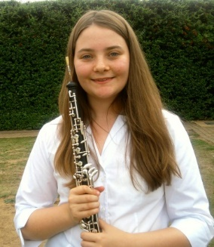**Vanessa Hanson-Morris**

**Oboe/ Cor Anglais**

**E-mail:** vanessa.hanson-morris@student.rncm.ac.uk

**Mobile:** 07817 871926

**Address:** 13 Aldwych Avenue, Manchester, M14 5NL.

**Education**

* Royal Northern College of Music. September 2012- July 2017.

BMus (Hons), studying Oboe Performance.

* The Purcell School. September 2010- July 2012. (Gifted and Talented Boarding Scholarship).

**Teachers**

Oboe: Jennifer Galloway (Prior studies with Jonathan Small, Melanie Ragge and Jenni Phillips)

Cor Anglais: Rachel Pankhurst and Thomas Davey

Baroque Oboe: Tony Robson

**Prizes and Awards**

* The Dr William Dobie Award (RNCM)
* The John Wills Prize for outstanding services to outreach (Purcell School)

**Orchestral Experience**

2016 Royal Marines Band Service (Placement), Principal Oboe and Cor Anglais

2015 RNCM Symphony Orchestra, Cor Anglais

Buxton Musical Society, Principal and 2nd Oboe

Sale Chamber Orchestra, Principal Oboe

Cheshire Sinfonia, 2nd Oboe

Piccadilly Symphony Orchestra, Principal Oboe and Cor Anglais

2014 RNCM Symphony Orchestra at Bridgewater Hall, Cor Anglais

2012-2013 Hallé Youth Orchestra, Principal Oboe

2012 National Youth Wind Ensemble, Cor Anglais

2011-2012 Purcell School Symphony Orchestra, 2nd Oboe and Cor Anglais

2011 National Youth Wind Ensemble Asia Tour, Principal Oboe

**Recordings**

Jan 2016 RNCM Wind Orchestra, Chandos Records. 2nd Oboe and Cor Anglais

Sept 2015 RNCM Wind Orchestra, Polyphonic Records. Cor Anglais

Jul 2015 BBC Radio 4 Sunday Worship at Buxton Festival, Principal Oboe

May 2015 BBC Radio 4 Sunday Worship at Holy Trinity Platt Church, Oboe

**Masterclasses**

2016 Nicholas Daniel

2014 Stephané Rancourt and Hansjörg Schellenberger

2013 Gregor Witt and Pauline Oostenrijk

2012 Jonathan Kelly

**Chamber Music**

2016 RNCM Concerto Competition – Copland’s Quiet City- final

2015 RNCM Cross School Prize- Viento Ensemble- final

RNCM Trevor Wye woodwind chamber music prize- Viento Ensemble- highly commended

**Outreach**

**Referees**

Head of Wind, Brass and Percussion (RNCM): Principal Study Tutor:

John Miller Jennifer Galloway

Royal Northern College of Music Royal Northern College of Music

124 Oxford Road 124 Oxford Road

Manchester Manchester

M13 9RD M13 9RD

j.miller@rncm.ac.uk j.galloway@rncm.ac.uk

0161 907 5255 07771 234 567