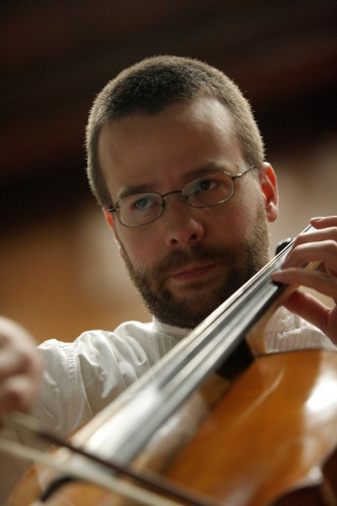
ŽELJKO IVOVIĆ, cello

Age : 32
Nikole Momčilovića 46, Stara Pazova, Serbia
Phone: +381 63 1013789
E mail: zeljko.ivovic@gmail.com
Languages: English, German

EDUCATION : 2001-2006 studied at the Music Conservatory at the University of Belgrade School of Music under professors Relja Cetkovic, Srdjan Sretenovic and Dejan Bozic. 2006-2010 earned Master Degree at University for Music and Applied Art in Graz – Oberschützen („Universität für Musik und Darstellende Kunst Graz”), Austria under Professor Tobias Stosiek.

MAJOR TEACHERS : Dejan Bozic and Tobias Stosiek.
-Master classes with : Milos Mlejnik (Slovenia), Ksenija Jankovic (Germany), Stanislav Apolin (Czech Republic), Stefan Popov (UK), Björn Sjögren (Norway), David Harrington from the Kronos quartet (USA) and Amernet string quartet (USA).

ORCHESTRAL EXPERIENCES :
-The Youth Symphony Orchestra of South-East Europe
-European Master Orchestra from Graz, Austria
-Belgrade Philharmonic Orchestra
-2008 - 2011: String Orchestra “Dušan Skovran” from Belgrade, Serbia
-Vojvodina Symphony Orchestra from Novi Sad, Serbia
-2014-2016 Solo-Cello at Kotor Art Festival orchestra in Kotor, Montenegro
-Collaborating with conductors : Jesus Medina (Mexico), Elisabeth Attl (Austria), Helder Trefzger (Brasil) , Nikolay Lalov (Portugal), and Claude Villaret (Switzerland).

FESTIVALS :
- Festival "Evmelia", -”Bemus” Festival, -”Nomus” Festival,
Agria, Greece Belgrade, Serbia Novi Sad, Serbia
-”Somus” Festival, -”Kotor Art” festival,
Sombor, Serbia Kotor, Montenegro

OTHER WORK EXPERIENCE :
-Since 2010. employed as a teacher at the School for Musicaly Gifted Children in Cuprija, Serbia
- Since 2011. member of „IL Belpaese“ string quartet

